|  |  |
| --- | --- |
| Date | 13 September 2022 |
| Team ID | PNT2022TMID50125 |
| Project Name | Containment Zones Alerting |
| Maximum Marks | 4 Marks |

Ideation Phase

BRAINSTORM & IDEA PRIORITIZATION TEMPLATE

Step-1:

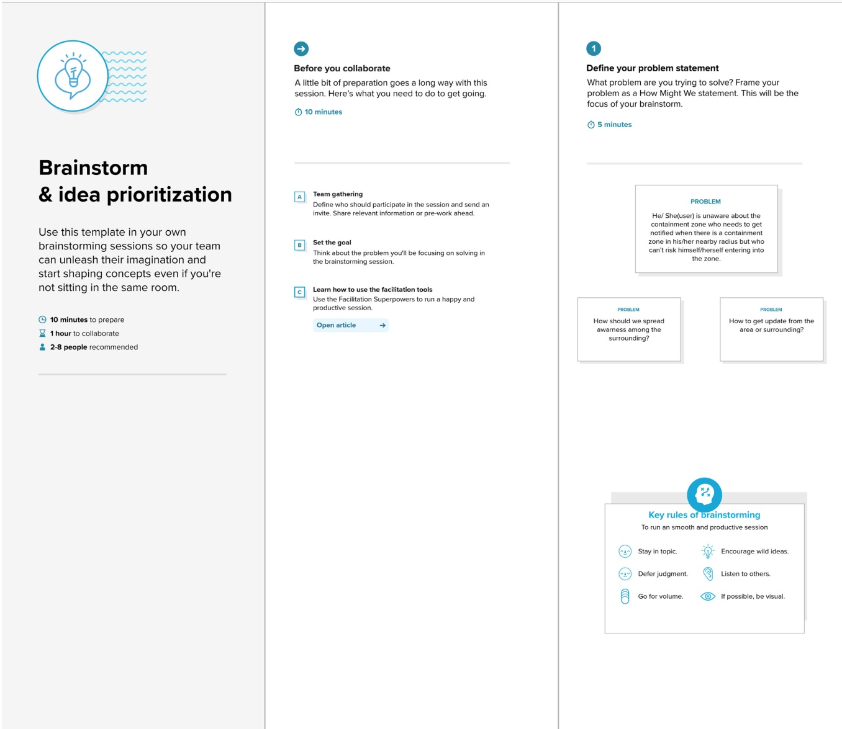

Ideation Phase

BRAINSTORM & IDEA PRIORITIZATION TEMPLATE

Step – 2:

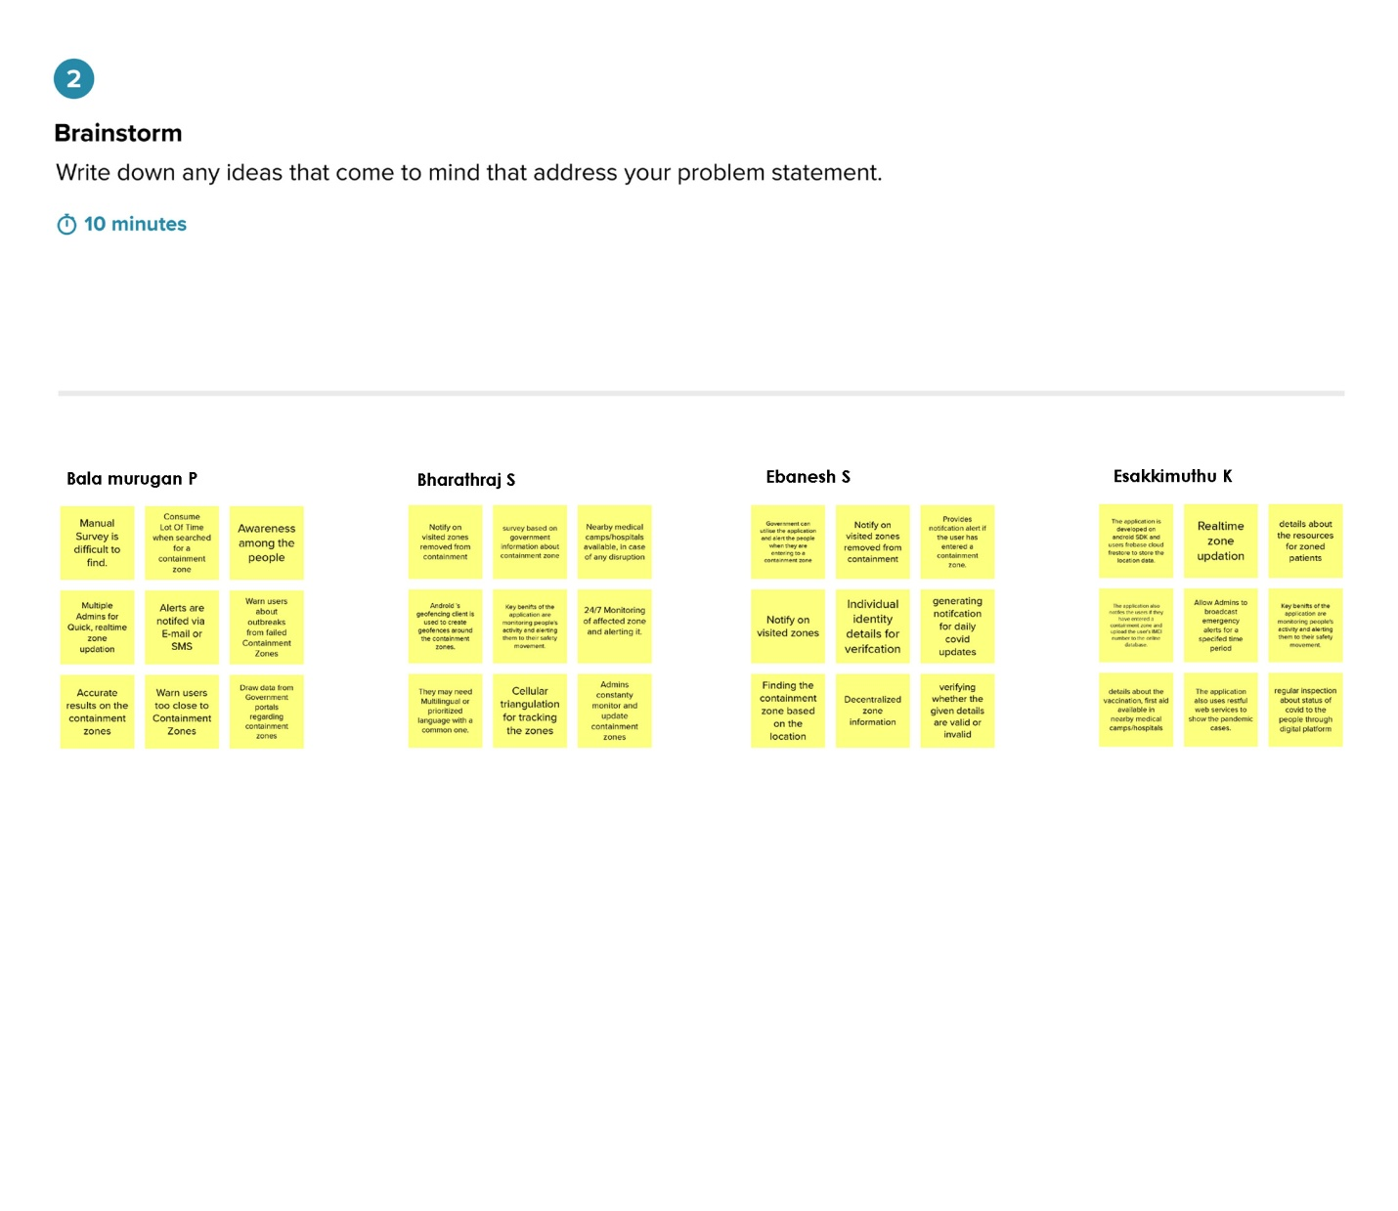

Ideation Phase

BRAINSTORM & IDEA PRIORITIZATION TEMPLATE

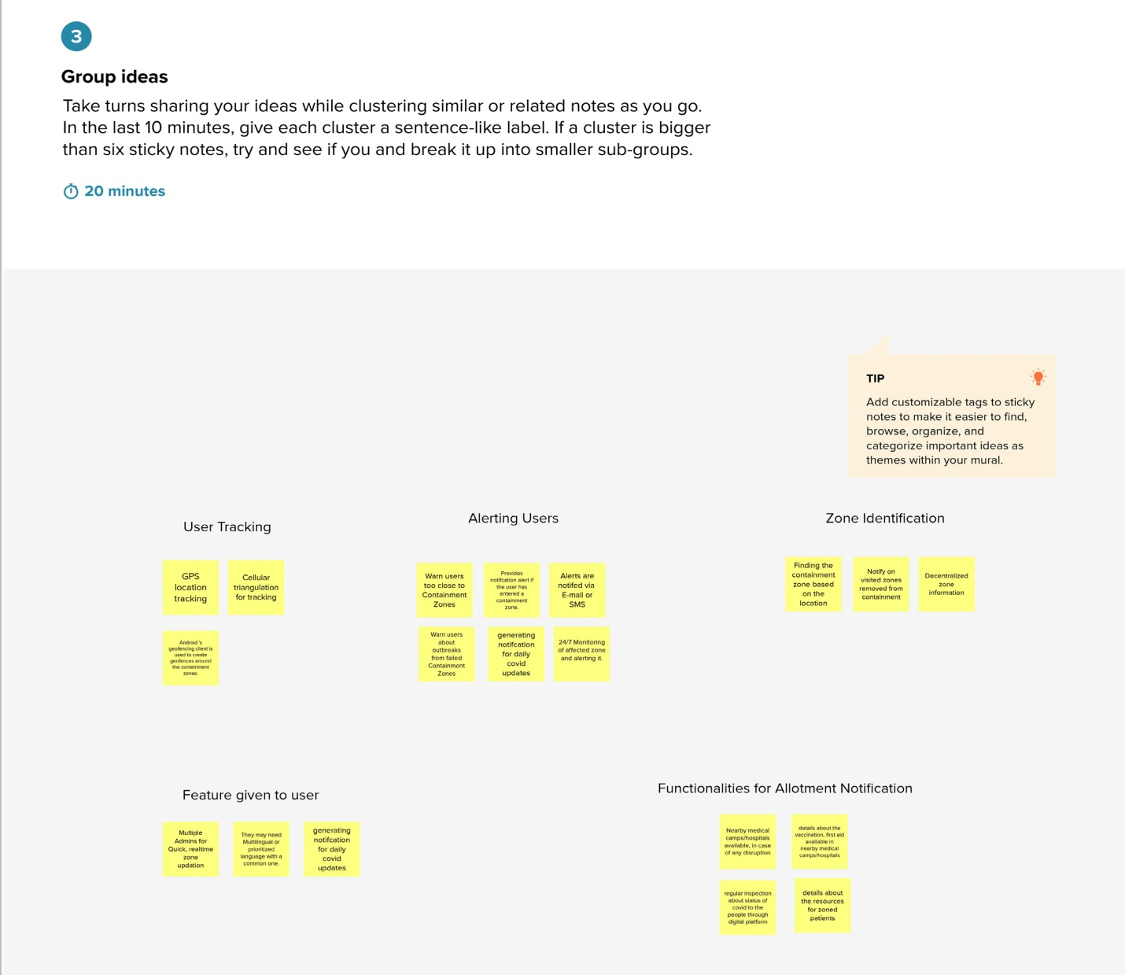

Ideation Phase

BRAINSTORM & IDEA PRIORITIZATION TEMPLATE

Step-3:

